International Journal of Industrial Engineering and Engineering Management (IJIEEM), Vol. x, No. x, [Month] [Year]

e-ISSN: 2685-4090 <http://ojs.uajy.ac.id/index.php/IJIEEM>

Type the paper title (15-20 words, Times New Roman, Bold, 20pt)

**First Author1,* and Second Author2**

1First affiliation: Department, Faculty, University, Country (11pt)

2Second affiliation: Department, Faculty, University, Country (11pt) Email: First author’s email, Second author’s email

*Corresponding author

# ABSTRACT

The abstract is a single, 150-300 word paragraph. Put more emphasis on the main conclusion and the implications of the proposed research than on specific numerical results. Write the abstract as a coherent story, starting with the research problem and then providing more information about the purpose, methods, results, and research implications.

**DOI:** https://doi.org/10.24002/ijieem.vxix.xxxx

**Keywords:** 3-5 keywords; alphabetical orders, e.g., analytical hierarchy process (AHP), poka-yoke, quality of education

**Research Type:** Review Paper/Research Paper/Case Study

**Article History:** Received, [Month] [Date], [Year]; Revised [Month] [Date], [Year]; Accepted [Month] [Date], [Year]

**How to cite:** APA reference style, e.g., Adrianto, E., & Suharyanti, Y. (2024). Marketing for higher education institution: A review and theoretical framework. *International Journal of Industrial Engineering and Engineering Management, 6*(2), 87-96.

## INTRODUCTION (BOLD, 10pt)

The introduction must contain a research problem, a solution, a state of the art, a novelty, a brief literature review from prior research, a research gap/novelty, and the most significant research contribution. Please thoroughly outline the issue and its resolution. The introduction should include at least one contribution, such as "The contribution of the research is."

The introduction, literature review, methodology, results and discussions, and conclusions make up the manuscript's structure.

## LITERATURE REVIEW (BOLD, 10pt)

This section contains comprehensive literature review. The literature review must examine the current state of research in the relevant topics to the presented research. It is advisable that the review is supported by a reputable international database. It is also recommended that the research gap and contribution be highlighted following the review.

## METHODOLOGY (BOLD, 10pt)

This section enables readers to critically assess the overall validity and reliability of your project or study by

outlining the justification for the use of particular approaches, methods, procedures, or techniques used to identify, select, and analyse information applied to understand the research problem or project.

Give a detailed description of any new techniques or strategies. Give a succinct and straightforward explanation of how well-established techniques and approaches are modified to meet the unique requirements and circumstances of the proposed study. Please use quote marks and provide credit to the original author if you are directly quoting from a previously published method. If there are any changes to the current procedures, provide a thorough description.

## RESULTS AND DISCUSSIONS (BOLD, 10pt)

The research findings and their discussion are included in the results and discussion. Put in writing the conclusions drawn from the completed research, which must be backed up by sufficient data. The research questions or hypotheses in the introduction must be addressed by the findings and results of the study. A scientific description of the discussion part is required. Please frame it in the manner shown below:

1. The study’s primary conclusions.
2. A comparison with the previous research.
3. Interpretation and justification of results.

2 Authors’ Names

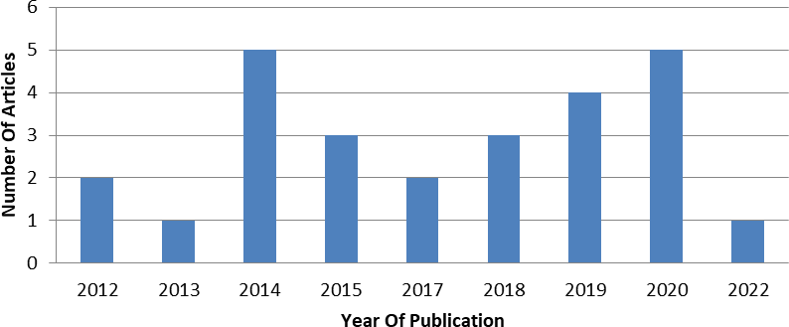

Figure 1. Years of publication

Table 1. Indiscernibility of information table

|  |  |  |  |  |  |
| --- | --- | --- | --- | --- | --- |
| IND A | IND B | IND C | IND D | IND E | IND F |
| X1 | X1 | X1 | X1 | X1 | X1 |
| X2 | X2 | X2 | X3 | X3 | X4 |
| X3 | X5 | X7 | X5 | X6 | X5 |
| X4 | X6 | X8 | X7 | X8 | X8 |
| X5 | X3 | X3 | X2 | X2 | X2 |
| X6 | X4 | X4 | X4 | X4 | X3 |
| X7 | X7 | X5 | X6 | X5 | X6 |
| X8 | X8 | X6 | X8 | X7 | X7 |

## Equation (Bold, 10pt)

The equation expression should be left-aligned when the equation expression should be left-aligned.

# REFERENCES

For guidance on how to format the reference material, please refer to the IJIEEM website's "Author Guidelines".

*Cp*  *Pi D*

(1)

Throughout the article, the author or authors should

Make sure that your equation's symbols have been defined either before or just after the equation.

## Figure and Tables (Bold, 10pt)

Place figures and tables at the top and bottom of columns if possible. If they are small, you can place them in the middle of columns. Table heads ought to be positioned above the tables, and figure captions beneath the figures. Following their citation in the text, include figures and tables. The figure should guarantee that the necessary data is shown appropriately, with readability and excellent resolution.

# CONCLUSION

Claim that the "Introduction" chapter's expectations can ultimately lead to the "Results and Discussion" chapter, demonstrating compatibility. Additionally, the possibility of expanding study findings and application opportunities for subsequent studies might be introduced (depending on outcome and discussion).

# ACKNOWLEDGMENT

You can acknowledge any assistance provided in this section. This could be in-kind contributions or technical and administrative assistance.

adhere completely to the APA reference style. The style has to be thoroughly examined for accuracy and completeness. At least 60% of the overall number of references should be the most current primary sources. Some of reference examples are:

Abebe, M., Park, J. W., & Kang, B. S. (2017). Reliability-based robust process optimization of multi-point dieless forming for product defect reduction. *International Journal of Advanced Manufacturing Technology*, *89*(1–4), 1223–1234.

Basha, N.K., Sweeney, J.C., & Soutar, G.N. (2019). Evaluating students’ preferences for university brands through conjoint analysis and market simulation. *International Journal of Educational Management*, *34*(2), 263-278.

Eldegwy, A., Elsharnouby, T.H., & Kortam, W. (2018). How sociable is your university brand? An empirical investigation of university social augmenters’ brand equity. *International Journal of Educational Management*, *32*(5), 912-930.

Foroudi, P., Dinnie, K., Kitchen, P.J., Melewar, T.C., & Foroudi, M.M. (2016). IMC antecedents and the consequences of planned brand identity in higher education. *European Journal of Marketing*, *51*(3), 528-550.

Girard, T., & Pinar, M. (2020). An empirical study of the dynamic relationships between the core and supporting brand equity dimensions in higher education. *Journal of Applied Research in Higher*

International Journal of Industrial Engineering and Engineering Management, Vol. x, No. x, [Month] [Year] 3

*Education*, *13*(3), 710-740.

Hamed, A., Jamil, S., & Rafiq, H.A. (2022). University branding and student satisfaction: The emerging landscape of universities in Pakistan. *Pakistan Journal of Educational Research*, *5*(2), 429-449.

Imaroh, T. S., & Mustofa, A. (2022). Defect reduction analysis to improve glass bottle packaging products quality using statistical process control (SPC) at PT. Muliaglass Container (MGC). *Journal of Social Science*, *3*(5), 1003–1018.

Jirasukprasert, P., Arturo Garza-Reyes, J., Kumar, V., &

K. Lim, M. (2014). A six sigma and DMAIC application for the reduction of defects in a rubber gloves manufacturing process. *International Journal of Lean Six Sigma*, *5*(1), 2–21.